Report Final Mobile Application Development

**Wikipedia Client**



Group 10 – BI10

University of Science and Technology of Hanoi

November 2021

**Members**

1. BI10-112 Nguyễn Hoàng Minh
2. BI10-118 Nguyễn Quý Minh
3. BI9-153 Lê Phước Long
4. BI10-089 Phạm Trung Kiên
5. BI9-133 Đặng Hùng Kiên

**Author**

BI10-112 Nguyễn Hoàng Minh

**Editor**

BI10-118 Nguyễn Quý Minh

I) Introduction 4

a) Briefing 4

b) Design Philosophy 4

II) Design 6

III) Method 7

a) UML 7

b) Important Libraries 8

b.1) Retrofit API 8

b.2) OkHttp3 9

b.3) RoomDataBase 9

IV) Development History 11

Phase 1(Before Mid-Term) 11

Phase 2(After Mid-Term) 11

V) Result 14

VI) Extra Features 19

VII)Reference 20

VIII) Contribution 20

# I) Introduction

# a) Briefing

- Wikipedia as we know has become one of the most popular Encyclopedia on the Internet. It contains a huge amount of knowledge with more than 55,632,716 articles[1]>>, support 325 languages, and a simple and easy to navigate and explore design. With that amount of coverage, Wikipedia has proved to be a necessary part of our day-to-day life. Thus in this project, we aim ourselves with the task of bringing Wikipedia on to go on your mobile Android devices to make it fast and easier to access Wikipedia.

# b) Design Philosophy

- Wikipedia has a clean Black and White design to improve help its user to focus on the reading experience we will try to translate into our application

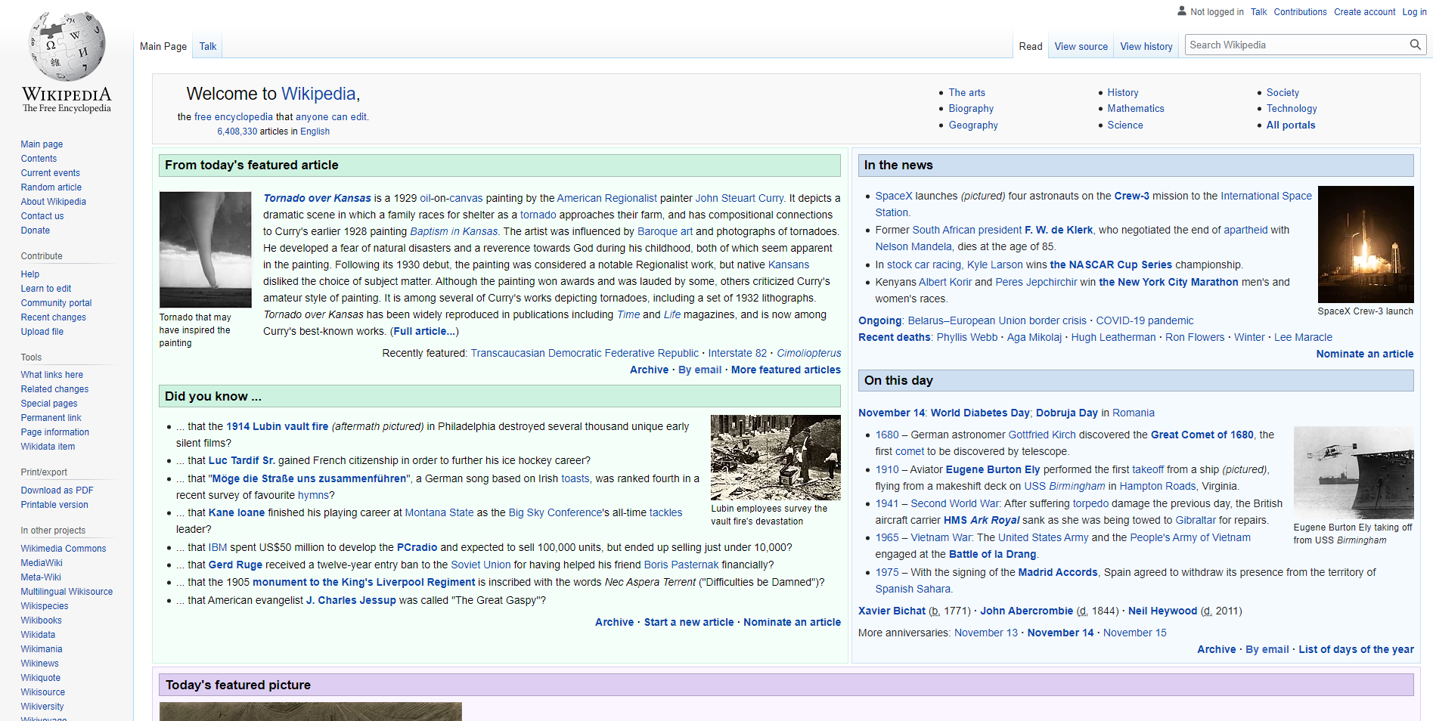

Figure 1: Wikipedia Main Page

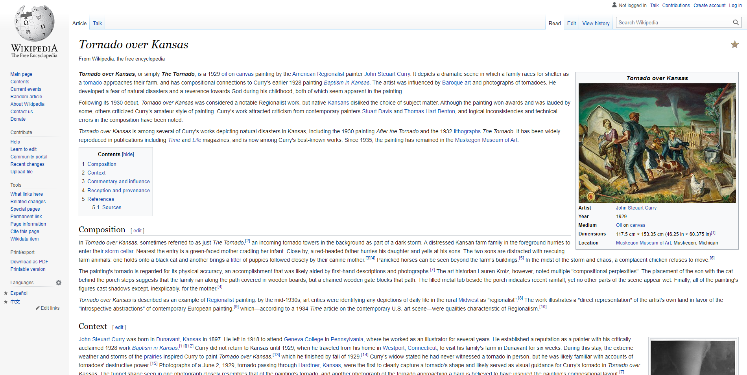

Figure 2: Wikipedia Article Page

-The app should be easy to navigate and manage to provide crucial information for the user about the happening event around the world.

-With the in mind we come up with the first variant of our UI.

# II) Design

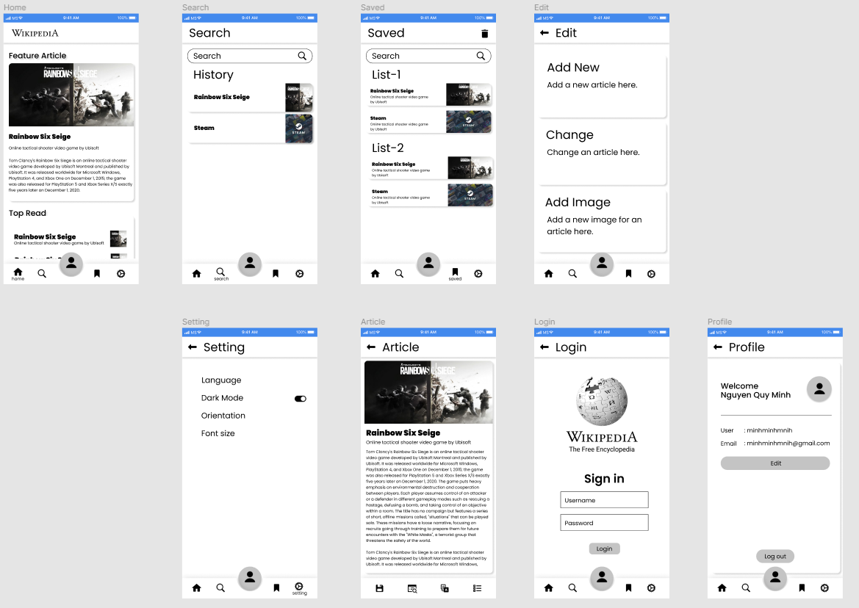

Figure 3: Figma Design

# III) Method

# a) UML

USE Case UML:

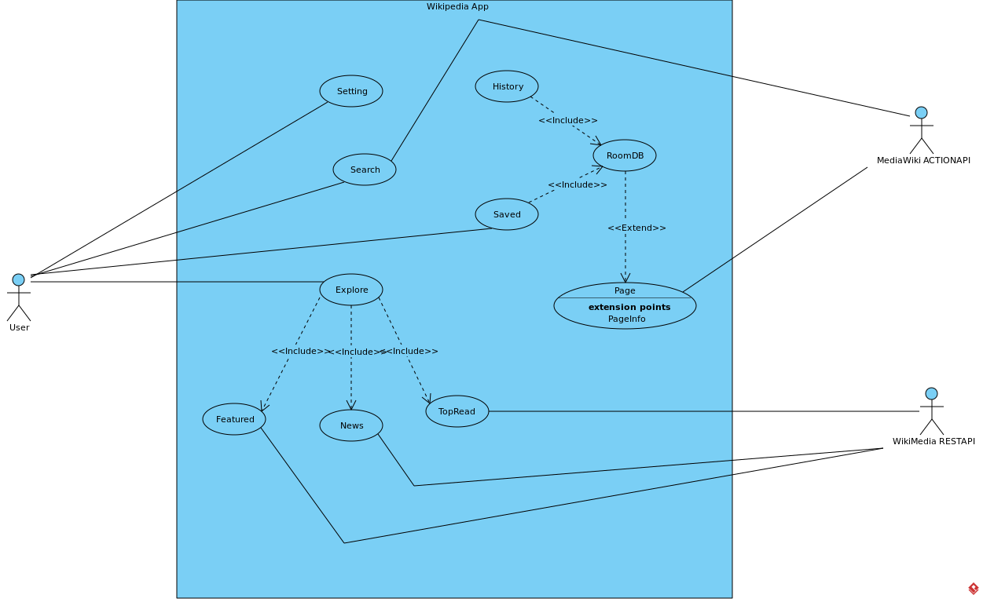

Figure 4: USE Case UML

Class UML



Figure 5: Class UML [3]

# b) Important Libraries

## b.1) Retrofit API

Retrofit is a REST Client for Java and Android. It helps you to retrieve and upload JSON (or other structured data) via a REST based web-service.

Why we choose Retrofit over Volley or AsyncTask:

* Retrofit offer a better performance across the board compare to the other two.

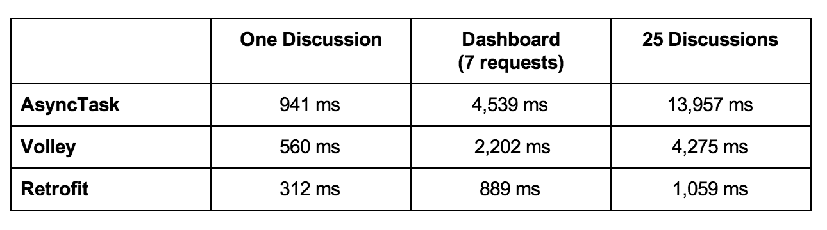

## b.2) OkHttp3

OkHttp3 offer alongside with Retrofit as Square’s meticulous HTTP client. At the current state of the project we only use OkHttp3 to create client and get the Logging of our API call using **HttpLoggingInterceptor.**

Figure 6: Logging

## b.3) RoomDataBase

The Room persistence library provides an abstraction layer over SQLite to allow fluent database access while harnessing the full power of SQLite. While speed and flexibility is no where near SQlite, it’s much more simple, support by Google themselves so open up for a lot more support if error ever occur during the making process. A full comparison between local database options can be found here [2]

- For our project we will implement RoomDB for locally saving user’s History and Saved articles.

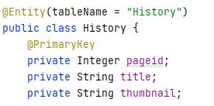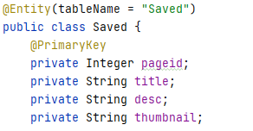

# 

# IV) Development History

# Phase 1(Before Mid-Term)

* In this phase we focus on create a working prototype based on the Wikipedia Mobile App thus come the first Figma Design.
* Home Fragment got created using RecyclerView. We use freeloaded data and a RecyclerView Filter to get the Search Feature
* Applied RoomDB for Save

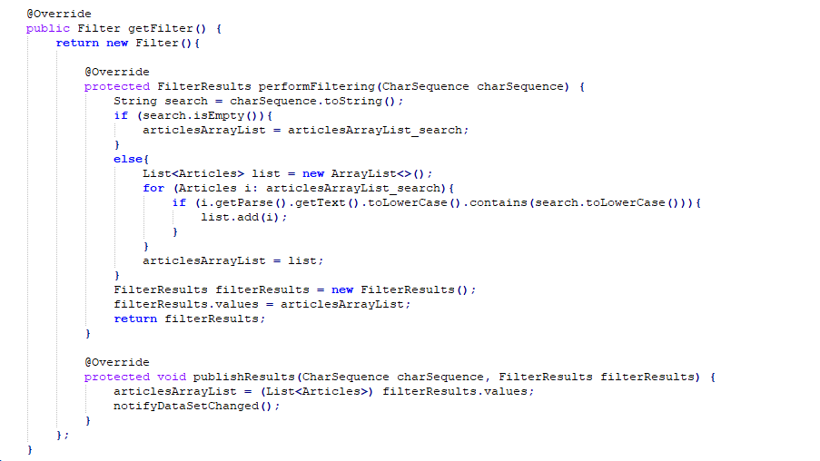

# Phase 2(After Mid-Term)

* In this phase we focus on apply Wiki API and drive our design and features with it.
* Home Fragment went from plain html parse(MediaWiki ActionAPI) to new Explore Fragment that keep the original Figma design and provide a better UI thanks to WikiMedia RestAPI.

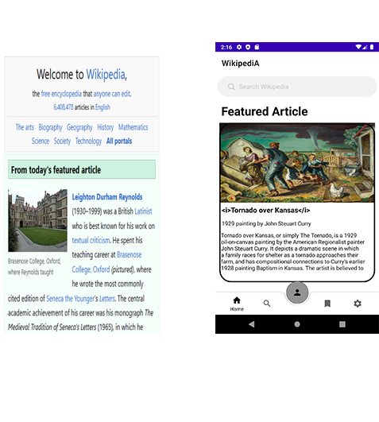

Figure 7: Old Home Frag vs New Explore Frag

* Searching Feature now breached into a Searching Activity. Rather than find Articles from a pre-set List, Searching will now get the List of Articles based on the input.

The full timeline can be found in the next page.

# V) Result

Accomplishment at the current state:

* Main Activity with 3 fragment Explore, Search/History, Save working
* Explore Frag update automatically everyday thank to WikiMedia RestAPI.
* Search Activity support live search using MediaWiki ActionAPI.
* RoomDB support History and Save.
* Retrieve Article using MediaWiki ActionAPI.
* Article Activity could Save and Search text in article content.
* Setting support for Dark Mode and Switching to different language.

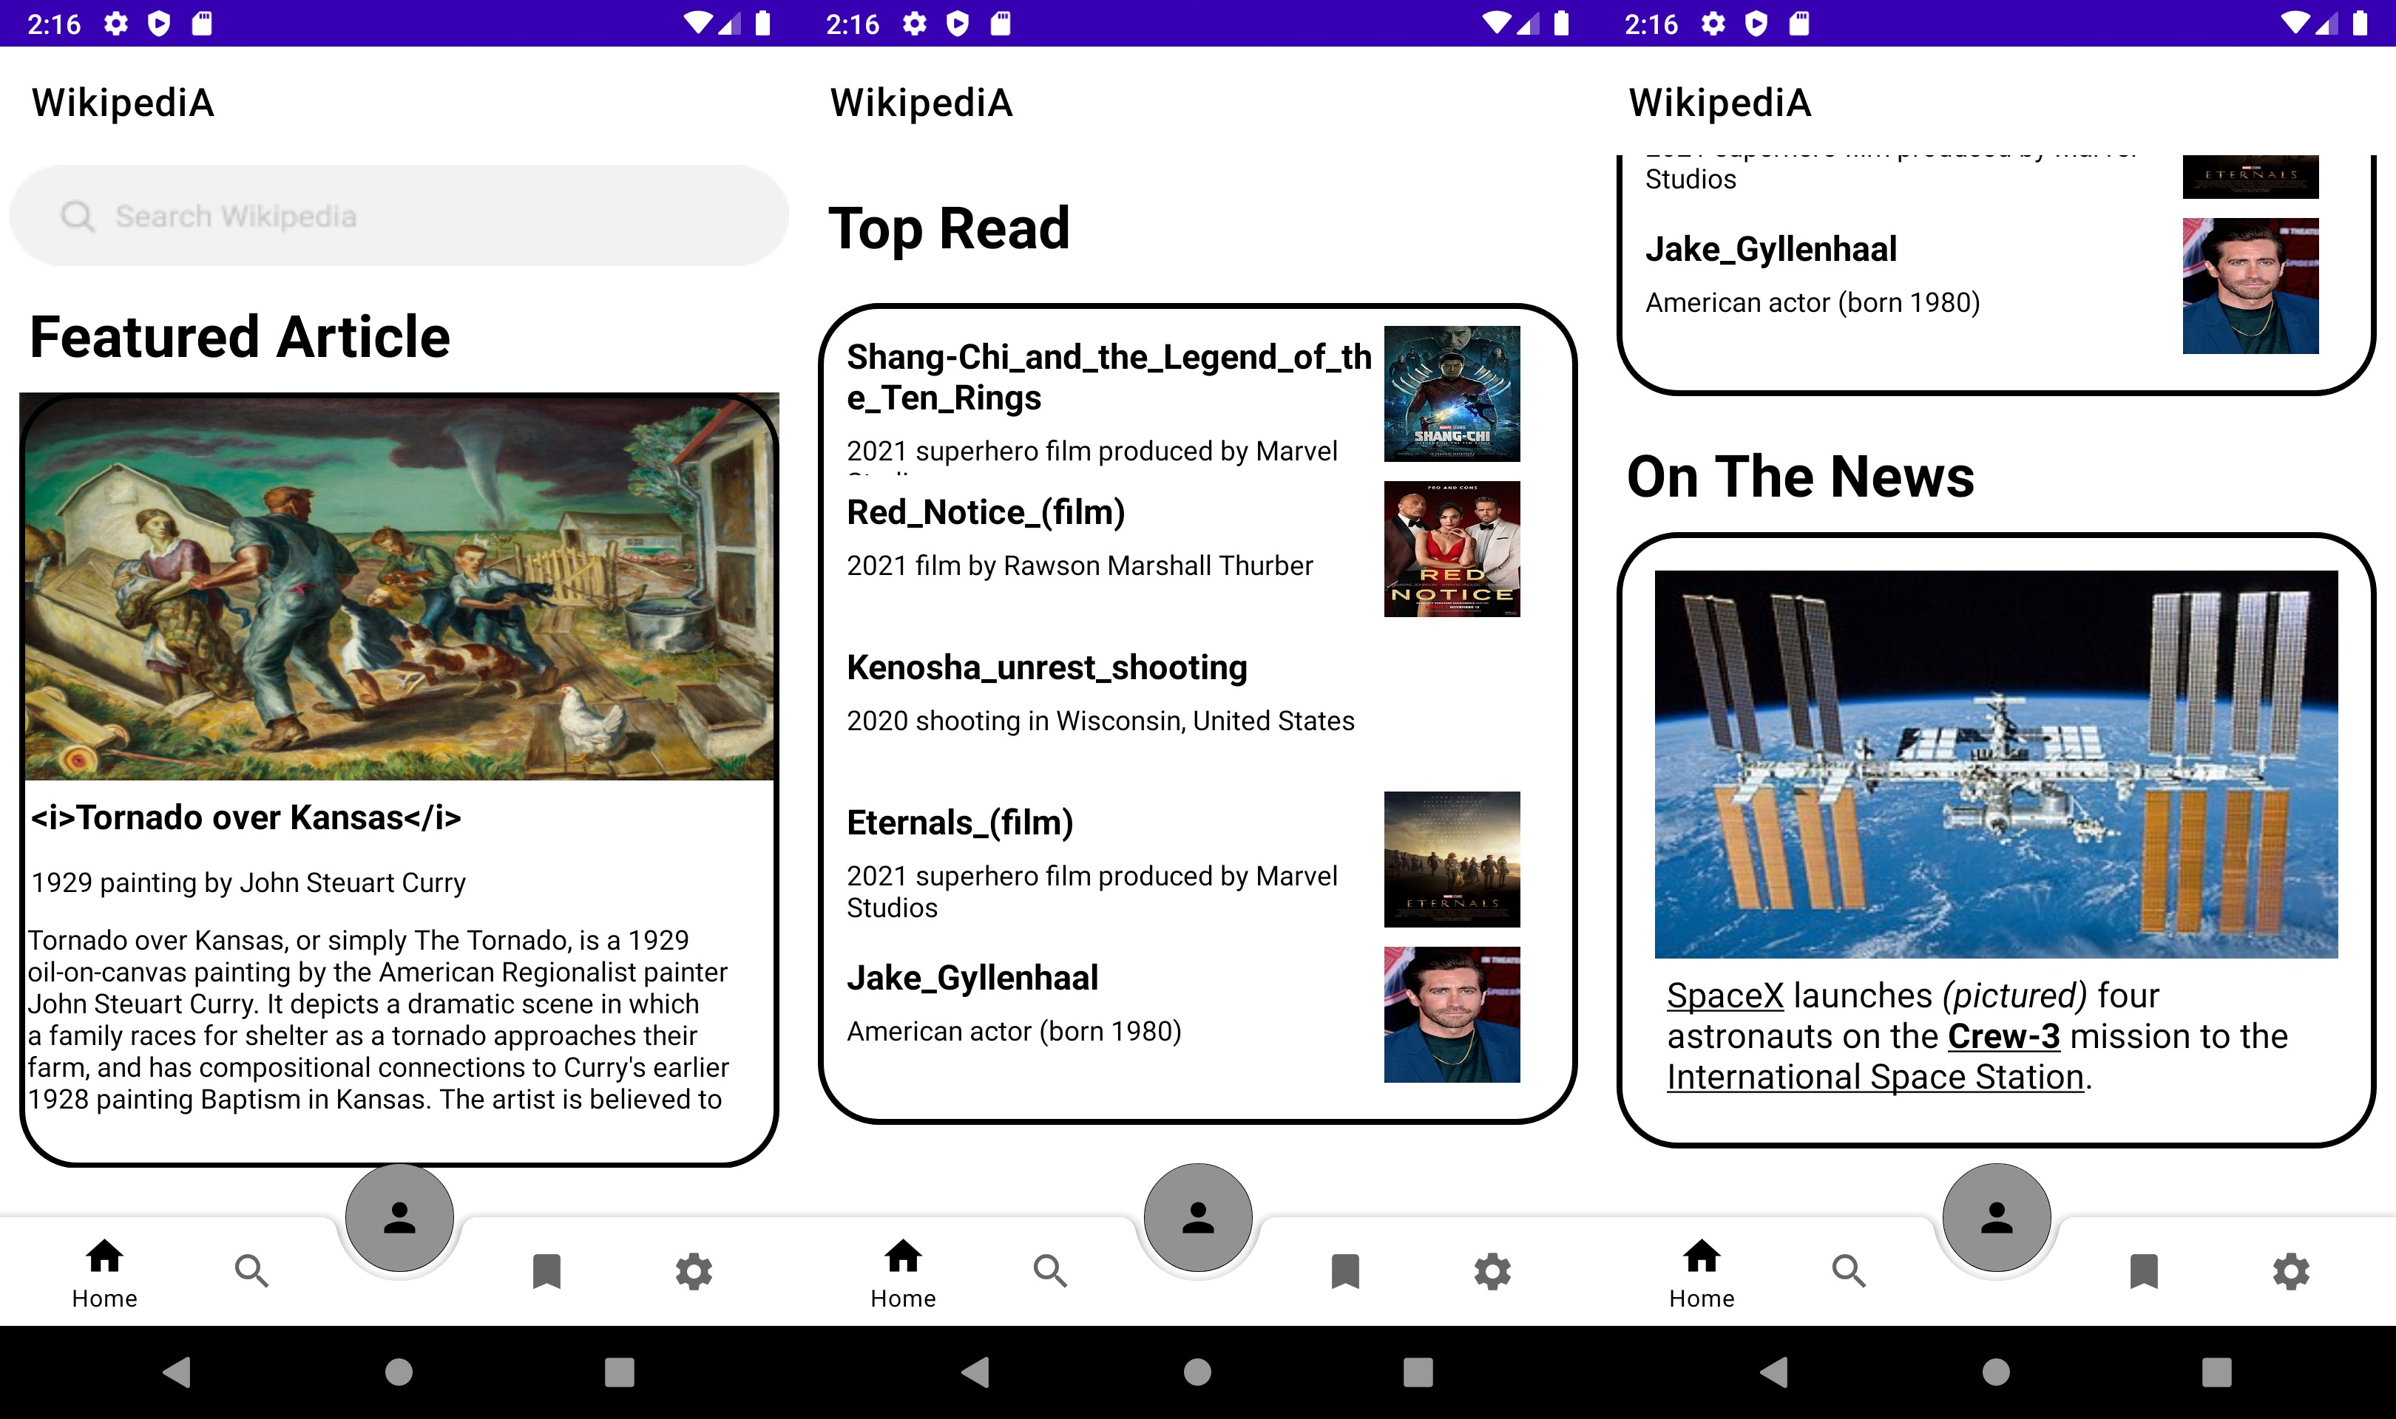

Figure 8: Explore Fragment

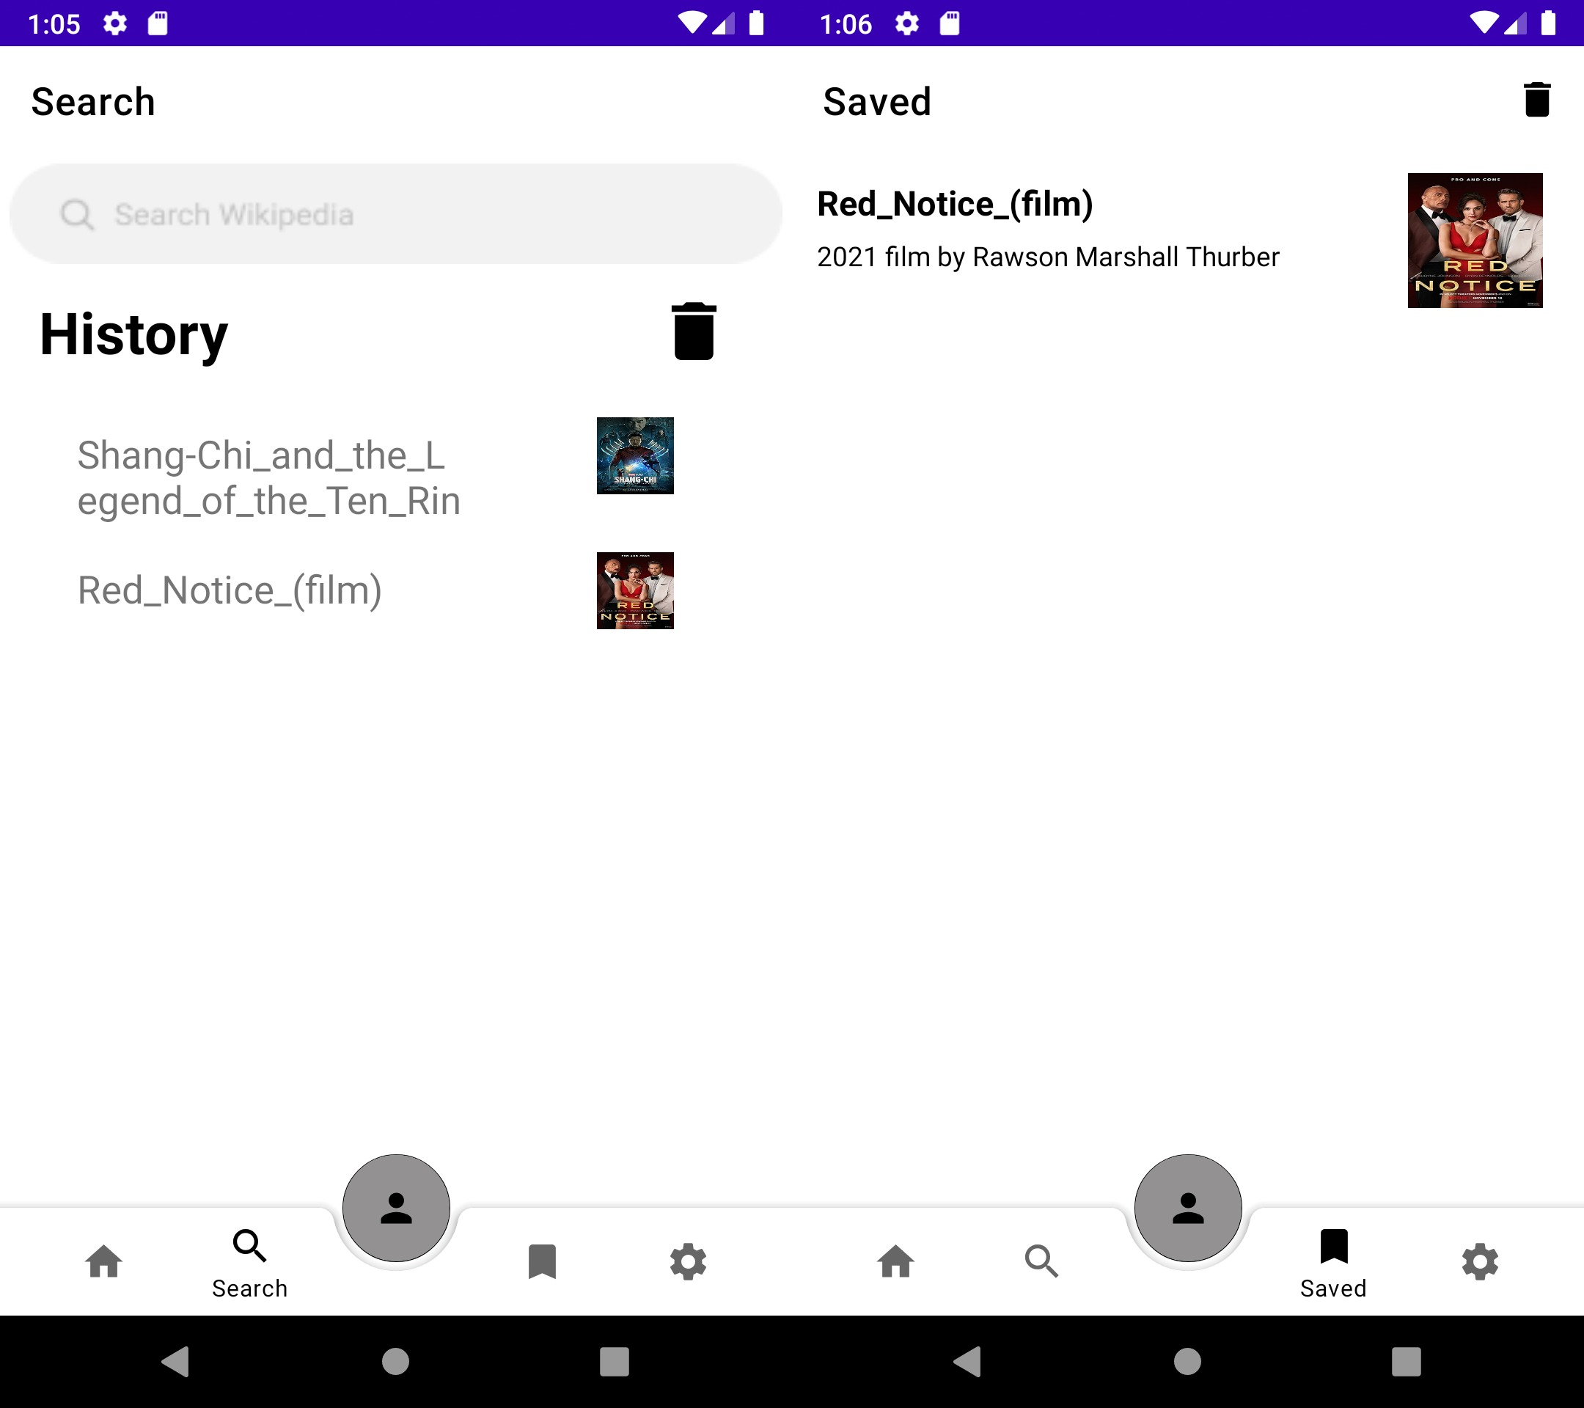

Figure 9: History/Save with RoomDB supported

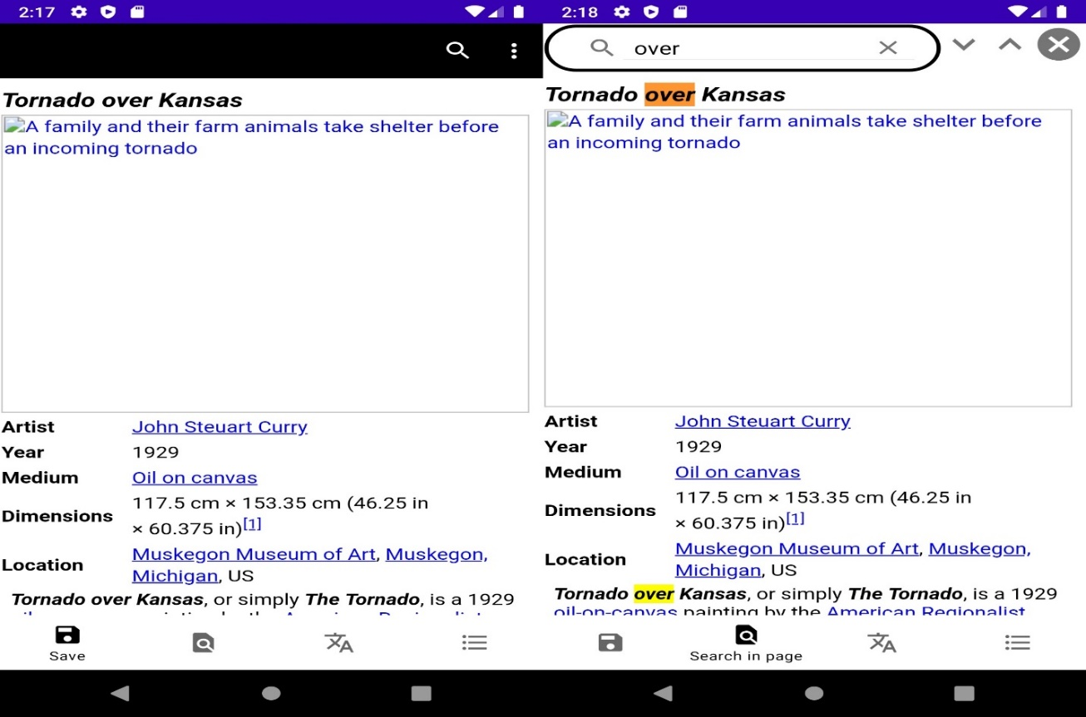

Figure 10: Articles with Save and Search

Figure 11: Changing Theme

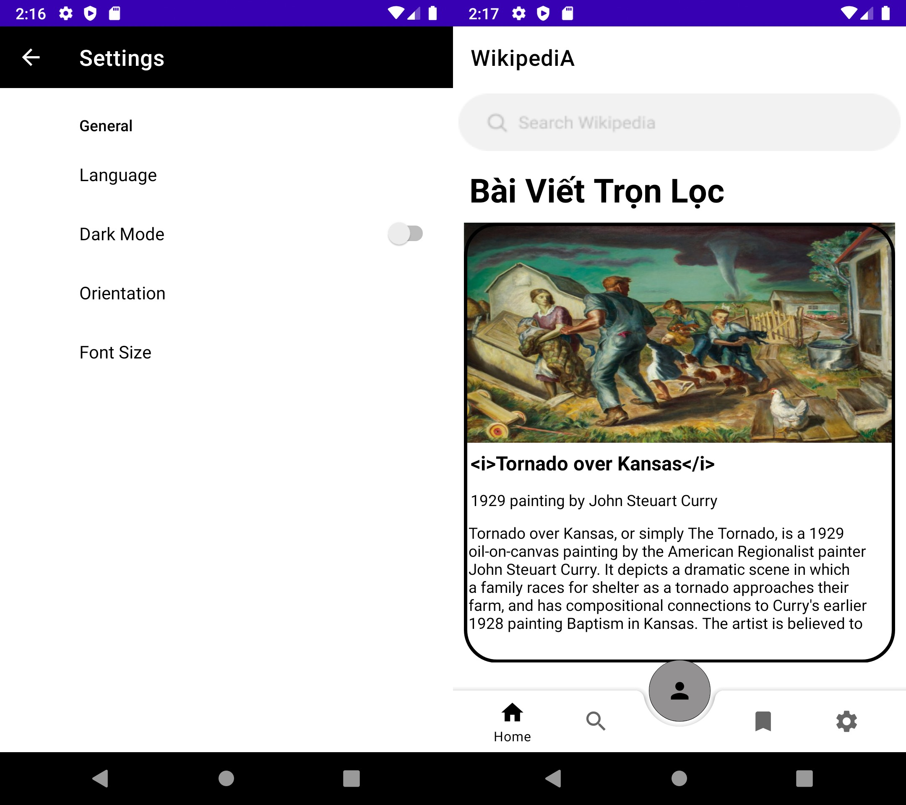

Figure 12: Changing Language

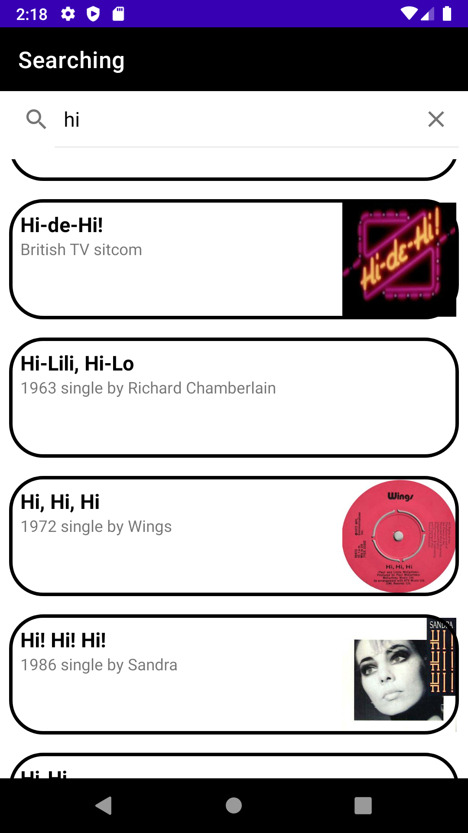

Figure 13: Live Searching

# VI) Extra Features

* Customized splash screen

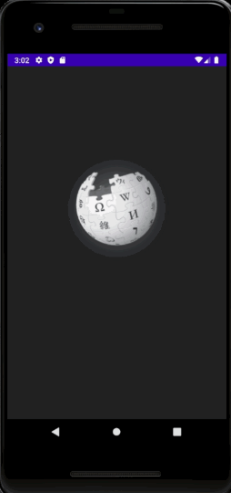

# 

# VII) Reference

[1] Guinness world records.(2020). Largest encyclopedia online. [Largest encyclopedia online | Guinness World Records](https://www.guinnessworldrecords.com/world-records/85651-largest-encyclopedia-online).

[2] AlexeyZatsepin.(2017). Android-ORM-benchmark. [GitHub - AlexeyZatsepin/Android-ORM-benchmark: Performance comparison of Android ORM Frameworks](https://github.com/AlexeyZatsepin/Android-ORM-benchmark)

[3] <https://drive.google.com/file/d/11q_8LZLGHCebvIWeikD2vgGdgSiuI826/view?usp=sharing>

(In case the UML in report not clear enough)

# VIII) Contribution

|  |  |
| --- | --- |
| **Name** | **Contribution** |
| Nguyen Hoang Minh | Code+Report Writer+Present |
| Nguyen Quy Minh | Figma Design+Slide+Present+Report Editor |
| Le Phuoc Long |  |
| Dang Hung Kien | Present+The other Report |
| Pham Trung Kien | Present+The other Report |